Activity | Data Type
Number of beatings from Wife | Discrete
Results of rolling a dice | Discrete
Weight of a person | Continuous
Weight of Gold | Continuous
Distance between two places | Continuous
Length of a leaf | Continuous
Dog's weight | Continuous
Blue Color | Discrete
Number of kids | Discrete
Number of tickets in Indian railways | Discrete
Number of times married | Discrete
Gender (Male or Female) | Discrete
Q1) Identify the Data type for the Following:

Q2) Identify the Data types, which were among the following
Nominal, Ordinal, Interval, Ratio.
Data | Data Type
Gender | Nominal
High School Class Ranking | Ordinal
Celsius Temperature | Interval
Weight | Ratio
Hair Color | Nominal
Socioeconomic Status | Interval
Fahrenheit Temperature | Interval
Height | Ratio
Type of living accommodation | Ordinal
Level of Agreement | Ordinal
IQ(Intelligence Scale) | Ratio
Sales Figures | Interval
Blood Group | Nominal
Time Of Day | Ratio
Time on a Clock with Hands | Ratio
Number of Children | Nominal
Religious Preference | Nominal
Barometer Pressure | Ratio
SAT Scores | Interval
Years of Education | Ratio

Q3) Three Coins are tossed, find the probability that two heads and one tail are obtained?
Answer : The total possible outcome 2^3=8
HHH,HHT,HTT,THT,TTH,HTH,THH,TTT
No of favorable outcomes =3
P=3/8=0.374

Q4) Two Dice are rolled, find the probability that sum is
- Equal to 1
- Less than or equal to 4
- Sum is divisible by 2 and 3
Ans:
Number of possible outcomes for the above event is
N (Event (Two dice rolled)) = 6^2 = 36
- P (sum is Equal to 1) = ‘0’ zero null nada none.
- P (Sum is less than or equal to 4) = N (Event (Sum is less than or equal to
4)) / N (Event (Two dice rolled))
= 6 / 36 = 1/6 = 0.166 = 16.66%
- P (Sum is divisible by 2 and 3) = N (Event (Sum is divisible by 2 and 3)) / N
(Event (Two dice rolled))
= 6 / 36 = 1/6 = 0.16 = 16.66%

Q5) A bag contains 2 red, 3 green and 2 blue balls. Two balls are drawn at random. What is the probability that none of the balls drawn is blue?

Ans: Total number of balls =7 balls
N (Event (2 balls are drawn randomly from bag) = 7! / 2! * 5!
= (7*6*5*4*3*2*1) /
(2*1) * (5*4*3*2*1)
N (Event (2 balls are drawn randomly from bag) = (7*6)/ (2*1) = 21
If none of them drawn 2 balls are blue = 7 – 2 = 5
N (Event (None of the balls drawn is blue) = 5! / 2! * 3! = (5*4) / (2*1)
= 10
P (None of the balls drawn is blue) = N (Event (None of the balls drawn is blue) /
N (Event (2 balls are drawn randomly from
bag)
= 10 / 21

Q6) Calculate the Expected number of candies for a randomly selected child
Below are the probabilities of count of candies for children (ignoring the nature of the child-Generalized view)
CHILD | Candies count | Probability
A | 1 | 0.015
B | 4 | 0.20
C | 3 | 0.65
D | 5 | 0.005
E | 6 | 0.01
F | 2 | 0.120
Child A – probability of having 1 candy = 0.015.
Child B – probability of having 4 candies = 0.20
Ans:
0.015+0.8+1.95+0.025+0.06+0.24 = 3.09

Q7) Calculate Mean, Median, Mode, Variance, Standard Deviation, Range & comment about the values / draw inferences, for the given dataset
- For Points,Score,Weigh>
Find Mean, Median, Mode, Variance, Standard Deviation, and Range and also Comment about the values/ Draw some inferences.
Use Q7.csv file
Q8) Calculate Expected Value for the problem below
- The weights (X) of patients at a clinic (in pounds), are
108, 110, 123, 134, 135, 145, 167, 187, 199
Assume one of the patients is chosen at random. What is the Expected Value of the Weight of that patient?
Ans:
Mean for Points = 3.59, Score = 3.21 and Weigh = 17.84
Median for Points = 3.69, Score = 3.32 and Weigh = 17.71
Mode for Points = 3.07, Score = 3.44 and Weigh = 17.02
Variance for Points = 0.28, Score = 0.95, Weigh = 3.19
Standard Deviation for Points = 0.53, Score = 0.97, Weigh = 1.78
Range [Min-Max] for Points [3.59 – 4.93], Score [3.21 – 5.42] and Weigh [17.84 – 22.9]
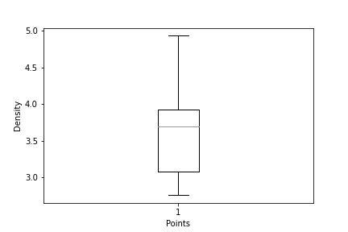
Draw Inferences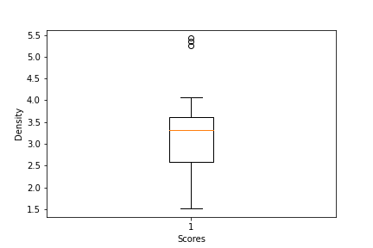
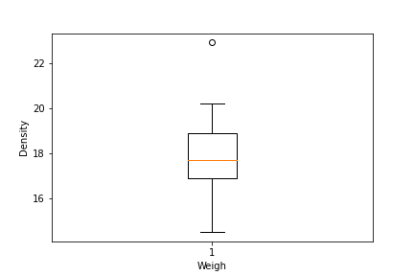

Q9) Calculate Skewness, Kurtosis & draw inferences on the following data
Cars speed and distance
Use Q9_a.csv
Ans :-
siddhi=read.csv('C:\\Users\\SIDDHI \\Downloads\\Q9_a.csv')
> #skewness and kurtosis for speed
> skewness(siddhi$speed)
[1] -0.1139548
> kurtosis(siddhi$speed)
[1] 2.422853
>
> #skewness and kurtosis for dist
> skewness(siddhi$dist)
[1] 0.7824835
> kurtosis(siddhi$dist)
[1] 3.248019

SP and Weight(WT)
Use Q9_b.csv

Ans :-
> siddhi=read.csv('C:\\Users\\SIDDHI\\Downloads\\Q9_b.csv')
> #skewness and kurtosis for SP
> skewness(siddhi$SP)
[1] 1.581454
> kurtosis(siddhi$SP)
[1] 5.723521
>
> #skewness and kurtosis for WT
> skewness(siddhi$WT)
[1] -0.6033099
> kurtosis(siddhi$WT)
[1] 3.819466

Q10) Draw inferences about the following boxplot & histogram

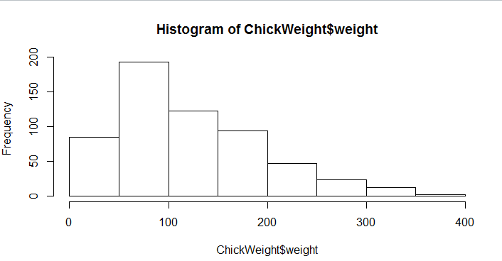
Ans: The histograms peak has right skew and tail is on right. Mean > Median. We have outliers on the higher side.

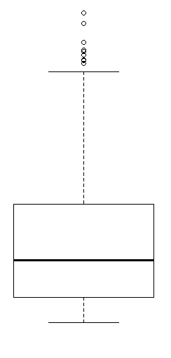

Ans: The boxplot has outliers on the maximum side.

Q11) Suppose we want to estimate the average weight of an adult male in Mexico. We draw a random sample of 2,000 men from a population of 3,000,000 men and weigh them. We find that the average person in our sample weighs 200 pounds, and the standard deviation of the sample is 30 pounds. Calculate 94%,98%,96% confidence interval?
Ans:
conf_94 =stats.t.interval(alpha = 0.94, df=1999, loc=200, scale=30/np.sqrt(2000))
print(np.round(conf_94,0))
print(conf_94)
For 94% confidence interval Range is [ 198.73 – 201.26]
For 98% confidence interval range is [198.43 – 201.56]
For 96% confidence interval range is [198.62 – 201.37]

Q12) Below are the scores obtained by a student in tests
34,36,36,38,38,39,39,40,40,41,41,41,41,42,42,45,49,56
- Find mean, median, variance, standard deviation.
Ans: Mean =41, Median =40.5, Variance =25.52 and Standard Deviation =5.05
- What can we say about the student marks?
Ans: we don’t have outliers and the data is slightly skewed towards right because mean is greater than median.
Q13) What is the nature of skewness when mean, median of data are equal?
Ans: No skewness is present we have a perfect symmetrical distribution
Q14) What is the nature of skewness when mean > median ?
Ans: Skewness and tail is towards Right
Q15) What is the nature of skewness when median > mean?
Ans: Skewness and tail is towards left
Q16) What does positive kurtosis value indicates for a data ?
Ans: Positive kurtosis means the curve is more peaked and it is Leptokurtic
Q17) What does negative kurtosis value indicates for a data?
Ans: Negative Kurtosis means the curve will be flatter and broader
Q18) Answer the below questions using the below boxplot visualization.
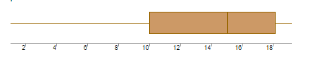
What can we say about the distribution of the data?
Ans: The above Boxplot is not normally distributed the median is towards the higher value

What is nature of skewness of the data?
Ans: The data is a skewed towards left. The whisker range of minimum value is greater than maximum
What will be the IQR of the data (approximately)?
Ans: The Inter Quantile Range = Q3 Upper quartile – Q1 Lower Quartile = 18 – 10 =8
Q19) Comment on the below Boxplot visualizations?
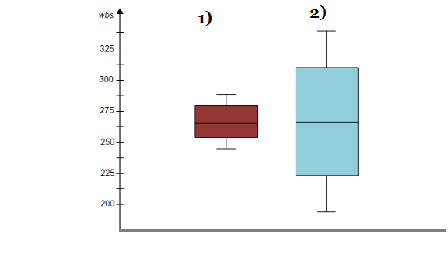
Draw an Inference from the distribution of data for Boxplot 1 with respect Boxplot 2.
Ans: First there are no outliers. Second both the box plot shares the same median that is approximately in a range between 275 to 250 and they are normally distributed with zero to no skewness neither at the minimum or maximum whisker range.

Q 20) Calculate probability from the given dataset for the below cases

Data _set: Cars.csv
Calculate the probability of MPG of Cars for the below cases.
MPG <- Cars$MPG
  - P(MPG>38)
Ans: Prob_MPG_greater_than_38 = np.round(1 - stats.norm.cdf(38, loc= q20.MPG.mean(), scale= q20.MPG.std()),3)
print('P(MPG>38)=',Prob_MPG_greater_than_38)

P(MPG>38)= 0.348

  - P(MPG<40)
Ans: prob_MPG_less_than_40 = np.round(stats.norm.cdf(40, loc = q20.MPG.mean(), scale = q20.MPG.std()),3)
print('P(MPG<40)=',prob_MPG_less_than_40)

P(MPG<40)= 0.729

  - P (20<MPG<50)
Ans: prob_MPG_greater_than_20 = np.round(1-stats.norm.cdf(20, loc = q20.MPG.mean(), scale = q20.MPG.std()),3)
print('p(MPG>20)=',(prob_MPG_greater_than_20))
p(MPG>20)= 0.943

prob_MPG_less_than_50 = np.round(stats.norm.cdf(50, loc = q20.MPG.mean(), scale = q20.MPG.std()),3)
print('P(MPG<50)=',(prob_MPG_less_than_50))
P(MPG<50)= 0.956

prob_MPG_greaterthan20_and_lessthan50= (prob_MPG_less_than_50) - (prob_MPG_greater_than_20)
print('P(20<MPG<50)=',(prob_MPG_greaterthan20_and_lessthan50))
P(20<MPG<50)= 0.013000000000000012

Q 21) Check whether the data follows normal distribution
- Check whether the MPG of Cars follows Normal Distribution
Dataset: Cars.csv
Ans:
- MPG of cars follows normal distribution
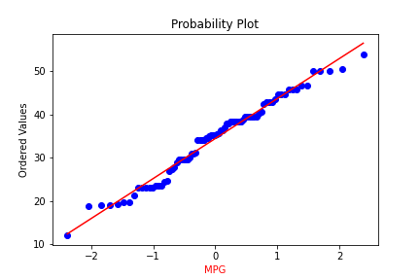

- Check Whether the Adipose Tissue (AT) and Waist Circumference(Waist) from wc-at data set follows Normal Distribution
Dataset: wc-at.csv
Ans: Adipose Tissue (AT) and Waist does not follow Normal Distribution
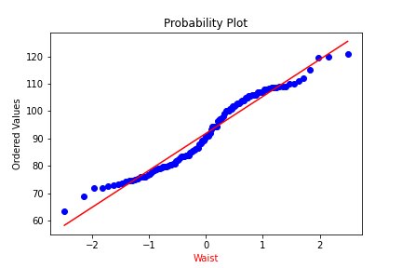

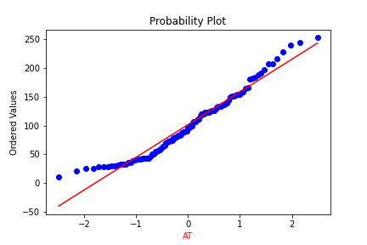
Q 22) Calculate the Z scores of 90% confidence interval,94% confidence interval, 60% confidence interval
Ans:
# z value for 90% confidence interval
print('Z score for 60% Conifidence Intervla =',np.round(stats.norm.ppf(.05),4))
Z score for 60% Conifidence Intervla = -1.6449

# z value for 94% confidence interval
print('Z score for 60% Conifidence Intervla =',np.round(stats.norm.ppf(.03),4))
Z score for 60% Conifidence Intervla = -1.8808

# z value for 60% confidence interval
print('Z score for 60% Conifidence Intervla =',np.round(stats.norm.ppf(.2),4))
Z score for 60% Conifidence Intervla = -0.8416

Q 23) Calculate the t scores of 95% confidence interval, 96% confidence interval, 99% confidence interval for sample size of 25
Ans:
# t score for 95% confidence interval
print('T score for 95% Confidence Interval =',np.round(stats.t.ppf(0.025,df=24),4))
T score for 95% Confidence Interval = -2.0639

# t value for 94% confidence interval
print('T score for 94% Confidence Inteval =',np.round(stats.t.ppf(0.03,df=24),4))
T score for 94% Confidence Inteval = -1.974

# t value for 99% Confidence Interval
print('T score for 95% Confidence Interval =',np.round(stats.t.ppf(0.005,df=24),4))
T score for 95% Confidence Interval = -2.7969

Q 24) A Government company claims that an average light bulb lasts 270 days. A researcher randomly selects 18 bulbs for testing. The sampled bulbs last an average of 260 days, with a standard deviation of 90 days. If the CEO's claim were true, what is the probability that 18 randomly selected bulbs would have an average life of no more than 260 days
Hint:
rcode pt(tscore,df)
df degrees of freedom
Ans: import numpy as np
Import scipy as stats
t_score = (x - pop mean) / (sample standard daviation / square root of sample size)
(260-270)/90/np.sqrt(18))
t_score = -0.471
stats.t.cdf(t_score, df = 17)
0.32 = 32%

